USE CASE:

User can manage money and review all the detail by date through this application.

User can type in the exact time range to check the saving and spending during time of period. For example, type in from 2020-03-01 to 2020-04-30 the result will only between this two time line. Can check the detail clearly instead search randomly. They can also type in the amount of their desire search requirement to find out the history.

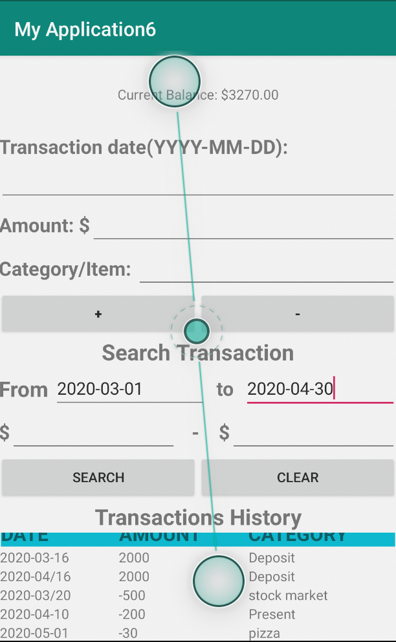

User can scroll down to check whole history.

